Strategic Product Placement Analysis Using Tableau
Team Member Name:
1.Mohit Jaiswal(202401100500108)
2.Rajat Chauhan(202401100500136)
3.Priyanshu Jaiswal(202401100500133)
4.Priyanshu Joshi(202401100500134)
1. Introduction
In the modern retail environment, product placement plays a crucial role in influencing customer purchasing behavior. Businesses strategically position products in different store areas such as checkout counters, middle shelves, and promotional displays to maximize visibility and increase sales.
With the help of data analytics tools like Tableau, organizations can analyze large datasets and transform them into meaningful visual insights. Tableau allows businesses to create interactive dashboards that help identify sales patterns, customer preferences, and the effectiveness of different product placement strategies.
This project focuses on analyzing how product positioning impacts sales performance and consumer behavior. The insights derived from the analysis help businesses make data-driven decisions to improve marketing strategies and optimize product placement.

2. Problem Statement
Retail companies often invest heavily in marketing and product display strategies. However, they may not clearly understand:
- Which product placement generates the highest sales
- Which store areas attract the most customers
- How customer demographics influence purchasing behavior
The main problem is identifying which product placement strategy is most effective in driving revenue.
This project uses Tableau data visualization to analyze product placement strategies and provide insights that help businesses improve sales performance.

3. Objectives of the Project
The main objectives of the project are:
- To analyze the relationship between product placement and sales performance.
- To visualize sales trends using interactive dashboards.
- To identify high-performing store locations for product placement.
- To analyze customer demographics and purchasing behavior.
- To provide actionable recommendations to improve product positioning strategies.

4. Data Collection
The dataset used in this project contains information related to product sales, placement locations, and customer demographics.
Dataset Attributes
Column Name | Description
Order_ID | Unique transaction identifier
Date | Date of purchase
Product_Name | Name of the product
Category | Product category
Placement_Location | Location where product is placed
Store_Area | Store section
Customer_Age_Group | Age group of the customer
Gender | Customer gender
Units_Sold | Quantity sold
Revenue | Total sales value
Example Data
Order_ID | Date | Product_Name | Category | Placement_Location | Units_Sold | Revenue
101 | 01-01-2024 | Chips | Snacks | Checkout Counter | 5 | 250
102 | 02-01-2024 | Soft Drink | Beverage | Middle Shelf | 3 | 180
103 | 03-01-2024 | Shampoo | Personal Care | Top Shelf | 2 | 300
The dataset was stored in Excel format and imported into Tableau for analysis.

5. Data Preparation
Before performing analysis, the dataset was cleaned and prepared.
Data Cleaning Steps
- Removed duplicate records.
- Handled missing values.
- Converted the date column into proper date format.
- Verified numeric fields such as Revenue and Units_Sold.
- Categorized fields into Dimensions and Measures.
Dimensions
- Product_Name
- Category
- Placement_Location
- Store_Area
- Customer_Age_Group
Measures
- Units_Sold
- Revenue

6. Data Visualization
Using Tableau, multiple visualizations were created to analyze the dataset.
Visualization 1: Sales Trend Over Time
Type: Line Chart
Purpose:
Shows how sales change across different months.
Fields Used:
- Date
- Revenue
Insight:
Helps identify seasonal sales patterns.

Visualization 2: Sales by Placement Location
Type: Bar Chart
Purpose:
Compares revenue generated from different product placements.
Fields Used:
- Placement_Location
- Revenue
Insight:
Helps determine the most profitable product placement.

Visualization 3: Product Category vs Sales
Type: Stacked Bar Chart
Purpose:
Compares sales performance across product categories.
Fields Used:
- Category
- Revenue
- Placement_Location

Visualization 4: Customer Demographics
Type: Pie Chart
Purpose:
Analyzes sales contribution from different age groups.
Fields Used:
- Customer_Age_Group
- Revenue

Visualization 5: Store Performance Heatmap
Type: Heatmap
Purpose:
Shows which store areas generate higher sales.
Fields Used:
- Store_Area
- Placement_Location
- Revenue

7. Dashboard Design
An interactive dashboard was created using Tableau to combine multiple visualizations.
Dashboard Components
The dashboard includes:
- Sales Trend Chart
- Sales by Placement Location
- Category Performance Chart
- Customer Demographics
- Store Performance Heatmap
Dashboard Filters
Interactive filters were added:
- Product Category
- Placement Location
- Customer Age Group
- Date Range
These filters allow users to dynamically explore the data.
Dashboard Layout
Top Section:
- Project Title
- Global Filters
Middle Section:
- Sales Trend
- Sales by Placement
Lower Section:
- Category Performance
- Customer Demographics
- Heatmap
The dashboard provides a comprehensive overview of product placement performance.
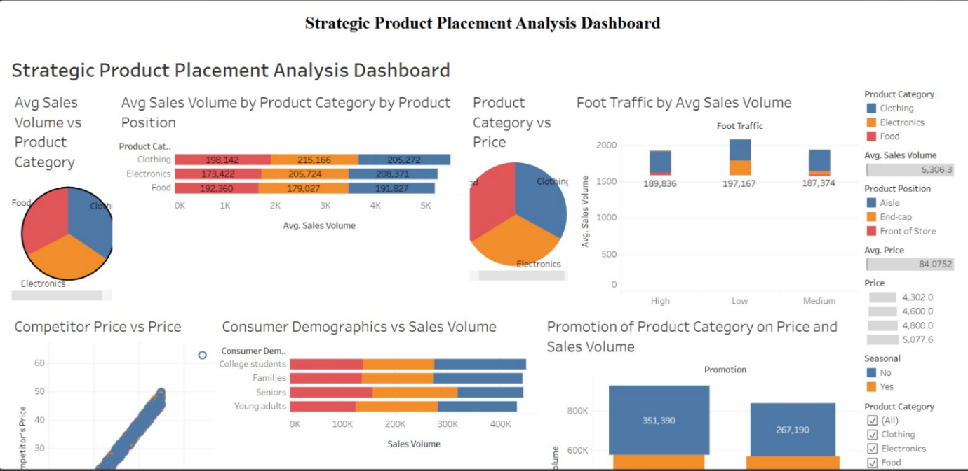

8. Story Creation
The Story feature in Tableau was used to present insights step by step.
Story Scene 1 – Introduction
Overview of dataset and business problem.
Story Scene 2 – Sales Trends
Analysis of sales patterns over time.
Story Scene 3 – Placement Strategy
Comparison of sales performance across placement locations.
Story Scene 4 – Customer Behavior
Insights into demographic purchasing patterns.
Story Scene 5 – Final Insights
Key recommendations for improving product placement.

9. Performance Testing
Performance testing ensures that the dashboard works efficiently.
Data Filters Used
- Category Filter
- Placement Location Filter
- Date Filter
- Age Group Filter
Calculated Fields Used
Total Sales
SUM([Revenue])
Average Sales
AVG([Revenue])
Revenue per Unit
SUM([Revenue]) / SUM([Units_Sold])
Visualizations Used
Total number of visualizations created:
- 6 Charts
- 1 Dashboard
- 1 Story with 5 scenes

10. Web Integration Using Flask
To make the dashboard accessible through a web interface, it was embedded using Flask.
Steps
- Publish the Tableau dashboard to Tableau Public.
- Copy the embed code.
- Create a Flask web application.
- Embed the dashboard inside an HTML page using an iframe.
Flask Application Example
from flask import Flask, render_template
app = Flask(__name__)
@app.route("/")
def dashboard():
return render_template("dashboard.html")
if __name__ == "__main__":
app.run(debug=True)
HTML Integration
<iframe src="TableauPublicDashboardLink"
width="100%" height="800"></iframe>
This allows users to interact with the dashboard through a web browser.
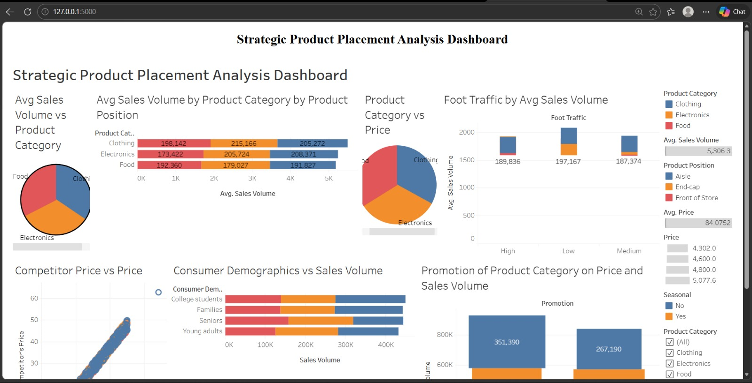
;::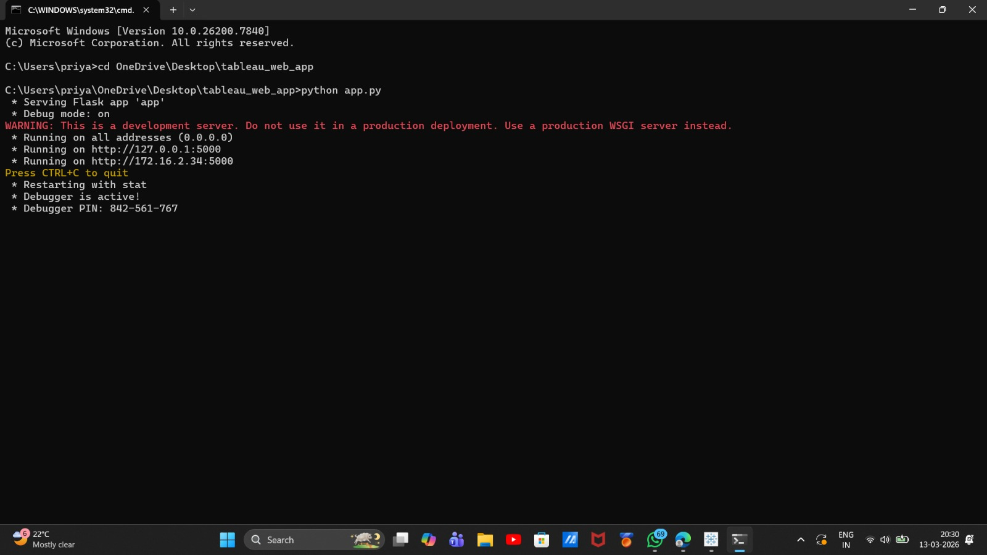
url:
http://172.16.2.34:5000

11. Results and Insights
From the analysis, the following insights were discovered:
- Products placed near the checkout counter generated higher impulse purchases.
- End-cap displays significantly increased snack and beverage sales.
- Customers aged 18-35 contributed the highest revenue.
- Promotional placements improved product visibility and sales.
These insights help businesses optimize their product placement strategies.

12. Conclusion
This project demonstrated how data analytics tools like Tableau can be used to analyze product placement strategies and their impact on sales.
By visualizing data through dashboards and stories, businesses can identify patterns in consumer behavior and improve marketing strategies.
The integration of the dashboard with Flask further enables organizations to share insights through web applications.
Overall, the project highlights the importance of data-driven decision making in retail marketing and product placement strategies.

